QUESTION#1

Make a simple calculator which performs basic arithmetic operations of mathematics such as addition, subtraction,

division and multiplication using scratch.

Solution:

**QUESTION#2**Make a simple temperature converter that converts Fahrenheit into Celsius.

Solution:

Celsius = ((Fahrenheit-32)*5)/9

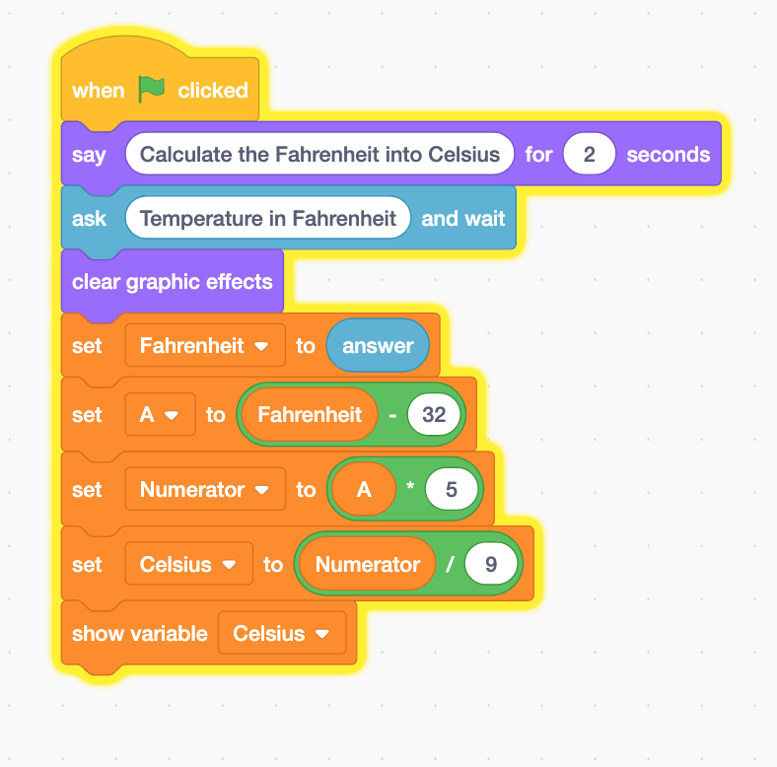

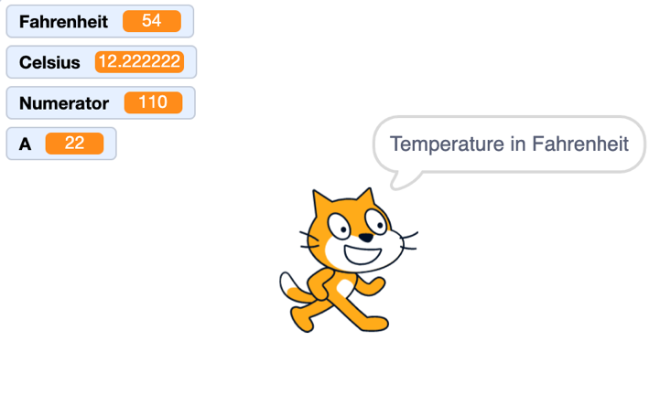

**QUESTION#3**

A bus leaves the university to take students on a field trip. The bus travels 10 kilometers south, 10 kilometers west, another 5 kilometers south and 15 kilometers north with the fuel consumption of 2 liters/km. Using scratch calculate how many kilometers it has covered and how much fuel it has consumed on a field trip?

Solution:

Total Kilometers= (Km_South+ Km_West+ Km_North)*Litre

**QUESTION#4**

Calculate the area for a triangle in which user inputs height and length of a triangle using scratch.

**QUESTION#5**  
Find out coordinates of midpoint using given formula, derived from Pythagorean Theorem and value of X by Quadratic formula using scratch, as follows:

1. Midpoint= ((x2+x1/2), (y2+y1/2))
2. Given (a≠0.)

**This type of question is already done above**

**QUESTION#6**

For 4 weeks, Waseem volunteered as a helper for swimming classes. The first week, he volunteered for 8 hours. He volunteered for 12 hours in the second week, and another 12 hours in the third week. The fourth week, he volunteered for 9 hours. Using scratch calculate how many hours did he volunteer per week, on average?

**Average: (8+12+12+9)/4**

**QUESTION#7**

A sweater is on sale for 25% off the original price. The original price is Rs. 5000. Using scratch calculate and print the sale price.

**Discount=Original price*25/100**

**Selling Price: Original price – Discount**

**QUESTION#8**

One of the jobs that Joe Roberts has been given at work is to order special paper for a report for a board meeting. The paper comes in reams of 500 sheets. He always makes five more copies than the number of people that will be there. Joe wants to know how many reams of paper he needs for a meeting. He can order only whole, not partial, reams. Assume the required number of pages will not equal an exact number of reams. Test your solution using scratch with the following data:

The report is 140 pages long.

There will be 25 people at the meeting.

**QUESTION#9**

Ali and Bilal are the friends. Write some greeting conversation in between them when clicked on the spirit?